**8.02 - FRIDAY COMPUTATIONAL THINKING - Week 1**

**HANDOUT (no coding required):**

**Physics Learning objectives**

* Reinforce your understanding of the vectors involved in the calculation of the electric field produced by a point charge
$$\vec{E}=k\frac{q_{S}}{{\left|{\vec{r}}_{P}-{\vec{r}}_{S}\right|}^{2}} {\hat{r}}_{SP}=kq_{S} \frac{ {\vec{r}}_{P}-{\vec{r}}_{S}}{ {\left|{\vec{r}}_{P}-{\vec{r}}_{S}\right|}^{3}}$$

* Reinforce your understanding of superposition
* Provide you with a visualization tool that you will be able to use as you work on new problems

(e.g. , you can make your analytical prediction, and then verify it numerically)

**CS Learning objectives**

* Review lists
* Review functions (why they are used, syntax)
* Review basic use of NumPy arrays
* Start developing an understanding of the role computation can play in solving problems.

**Syntax and Jupyter warmup (optional):**

<https://mybinder.org/v2/gh/ESG-802/spring21/HEAD?filepath=%2F0-%20Python%20warmup.ipynb>

**In class group problem solving:**

<https://mybinder.org/v2/gh/ESG-802/spring21/HEAD?filepath=%2F1-%20Electric%20Field%20Visualization.ipynb>

**INSTRUCTORS NOTES:**

This is the location or the original files: <https://mybinder.org/v2/gh/ESG-802/spring21/HEAD>

If you make changes the students will not see them unless you commit them in Github

<https://github.com/ESG-802/spring21>

The solutions are in a private repository.

**POSSIBLE EXTENSIONS**

1. Model water and other polar molecules. Estimate the dipole moments or the effective charges. **no coding required**

**Problem: water molecule**

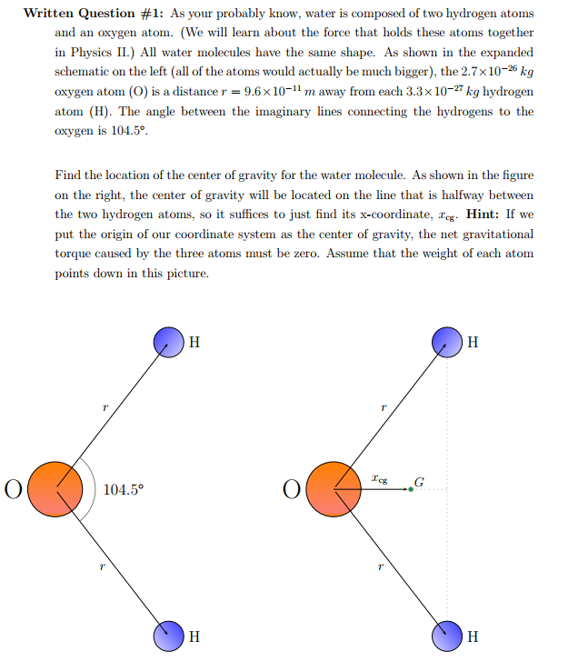

Water is a polar molecule. The H atoms are partially positively charged, and the O atom is partially negatively charged such that the whole molecule is neutral. Suppose the length of each O-H bond is $r$, the partial positive charge on a H atom is $δ$ and that the O atom is at the origin.

1. Calculate the electric dipole moment vector of the water molecule.
2. Calculate the E field produced by the water molecule at a general point on the positive x-axis $(x,0,0)$ such that $x>0.$
3. Solve for the point(s) where E=0 along the positive x-axis.
4. Use the E-field visualization code to model the water molecule in the picture above given $r=1m$ (normalized to 1 for simulation purposes) and $δ=0.1 nC.$ Visualize the field at two points on the x axis $(r,0,0)$ and $(1.5r,0,0)$ on two separate graphs. Does the visualization match your result from part c?

e) If the magnitude of the total dipole moment vector of the water molecule is given to be $6.1×{10}^{-30}$ C.m, find the absolute value of the effective partial charge $δ$ in Coulombs.

1. Model the force and torque on a uniform dipole

<https://www.compadre.org/PICUP/exercises/exercise.cfm?A=torqueondipole>

**Additional CS learning objectives that can be addressed with extension 2, with coding:**

* Solve an initial value problem
* Describe convergence